
Tuberculosis Data Analysis
  - Bojun Shi 501282997
Supervisor: Tamer Abdou
Submission: 2025-07-14
Table of Contents
Problem Statement and Context 3

Research Questions and Justification 3
Dataset Selection and Rationale 3
Proposed Methodology and Tools………………………………………………………....4
Literature Review……………………………………………………………………………4-7
Data Description……………………………………………………………………………..8-9
Project Approach…………………………………………………………………………..9-10

References Page……………………………………………………………………………………….11

Problem Statement and Context
Tuberculosis (TB) is an illness caused by bacteria that mainly affects the lungs. The earliest written records of TB disease were in India and China thousands of years ago and has caused millions of deaths. Today, we know that TB is spread through the air and we have more effective treatments. Since 2000, about 79 million lives have been saved through effective diagnosis and treatment. The global trends in tuberculosis data might reveal some surprising correlations between economic indicators and health outcomes. This dataset is ideal for policymakers, researchers, and data analysts aiming to study TB trends, evaluate healthcare interventions, and develop predictive models for disease control.

Research Questions and Justification
- How have TB incidence and mortality rates evolved over time across different income levels and world regions?
- Which socioeconomic, health, and demographic factors are the most important predictors of TB incidence rate across countries and years?"
- Do countries with higher BCG vaccination coverage have lower TB mortality rates, after controlling for health and socioeconomic factors?
Understanding who is at risk is fundamental to any public health strategy. TB is an infectious disease that can affect anyone, but risk levels vary due to socioeconomic status, immunity, health condition and geographic location. The BCG vaccine is one of the oldest still in use, but its effectiveness varies. Understanding its role in disease prevention directly addresses the theme of medical intervention and disease control.

Dataset Selection and Rationale

This dataset is from Kaggle.com and it provides comprehensive insights into global TB trends from the year 2000 to 2024 across multiple countries and regions. It includes 3,000 records covering TB incidence, mortality, treatment success, drug-resistant cases, and healthcare access, making it an invaluable resource for public health analysis, epidemiological research, and predictive modeling. The potential limitation to this dataset is that it is not divided by age group and does not provide us more insight about which age group is more vulnerable to the TB disease.

Proposed Methodology and Tools
RQ1 investigates long-term trends in TB incidence and mortality across countries, stratified by income level and world region. Using data from 2000 to 2020, the analysis focuses on identifying whether countries with different economic statuses or regional affiliations have experienced distinct patterns in reducing TB burden. Key variables include TB incidence and mortality rates, income level, region, and year. Linear regression models will be fitted to estimate the rate of change in TB burden for each group, and statistical tests like ANOVA will assess whether these changes are significantly different across groups.
RQ2 investigates the key predictors of Tuberculosis (TB) incidence rates across countries using a data-driven approach. The research question focuses on identifying which socioeconomic, health, and demographic factors are most strongly associated with higher TB incidence. The dataset includes variables such as GDP_Per_Capita, Health_Expenditure_Per_Capita, Urban_Population_Percentage, Malnutribution_Prevalence, Smoking_Prevalence, Access_to_health_services, HIV_Coinfected_TB_Case, BCG_Vaccination_Coverage, HIV_Testing_Coverage, and Population. Exploratory Data Analysis (EDA) will be conducted to understand underlying patterns and relationships. Multiple linear regression and random forest models will be applied to predict TB incidence rates and assess the relative importance of each predictor. Model performance will be evaluated using R² scores with a focus on achieving strong explanatory power and statistical significance.
RQ3 explores the variation in TB mortality rates across countries and investigates the key factors that contribute to higher TB mortality rates. It focuses on assessing the impact of public health investment, socioeconomic status and vaccination coverage on TB mortality. The analysis will use linear regression to quantify the contribution of each attribute and regression model. The strength and significance of predictors will be assessed using R-square values and p-values.
The findings will help illuminate the most influential drivers of TB incidence and may offer policy-relevant insights for disease prevention and resource allocation.

Literature review
Many studies have assessed the association between poverty and TB, and now we know that TB is more common in countries where many people live in poverty. People in these countries are more likely to live and work in poor ventilated and overcrowded conditions, which provide ideal conditions for TB bacteria to spread. Those who suffer from malnutrition and disease, particularly HIV, are also the most vulnerable. For instance, a study highlights a significant relationship between socio-economic status (SES) and the prevalence of TB in the district of Buner, Khyber Pakhtunkhwa, Pakistan. It was found that individuals from low SES backgrounds are more likely to suffer from TB compared to those from higher SES backgrounds. The research indicates that education plays a crucial role in TB prevalence and poverty is a major risk factor for TB. Individuals with lower education level had the highest rates of TB infection, while those with higher education level experienced significantly lower rates of the disease. The study also reported that low-income families count for 42% of TB cases, compared to 30% in middle-income families and 27.8% in high-income families.
According to WHO (World Health Organization), approximately one-third of the world’s population is infected with TB and globally, low income and lower middle income countries account for more than 90% of TB cases and deaths. In one cross-sectional study where epidemiological data were gathered and used, covering people with tuberculosis in 204 countries and 21 regions for 30 years from January 1, 1990 to December 31, 2019. It shows that globally, the TB cases has decreased in most part of the world from 1990 to 2019. The most cases of TB is in South Asia region.
Although these studies provide valuable insights, further research is needed to confirm the findings and explore the complexities of TB epidemiology in different contexts. For instance, one of these studies acknowledge significant geographic disparities in tuberculosis burden, but it may not fully account for local factors that influence these trends, such as socio-economic conditions, healthcare access, and public health policies can vary widely within regions, potentially skewing the overall findings. The limitation for the other study mentioned above is that the study is limited to the district of Buner in Khyber Pakhtunkhwa, Pakistan. This narrow geographical focus may not allow for generalization of the findings to other regions or populations, as socio-economic and health conditions can vary significantly across different areas. The research employs a cross-sectional survey design, which captures data at a single point in time. This design limits the ability to establish causal relationships between socio-economic status and tuberculosis prevalence. Longitudinal studies would provide more insight into how these factors interact over time. While the study examines socio-economic status and education, it may not account for other important factors that influence TB prevalence, such as nutrition, access to healthcare, and cultural beliefs. A more comprehensive approach considering a wider range of variables could provide a clearer picture of the TB epidemic.
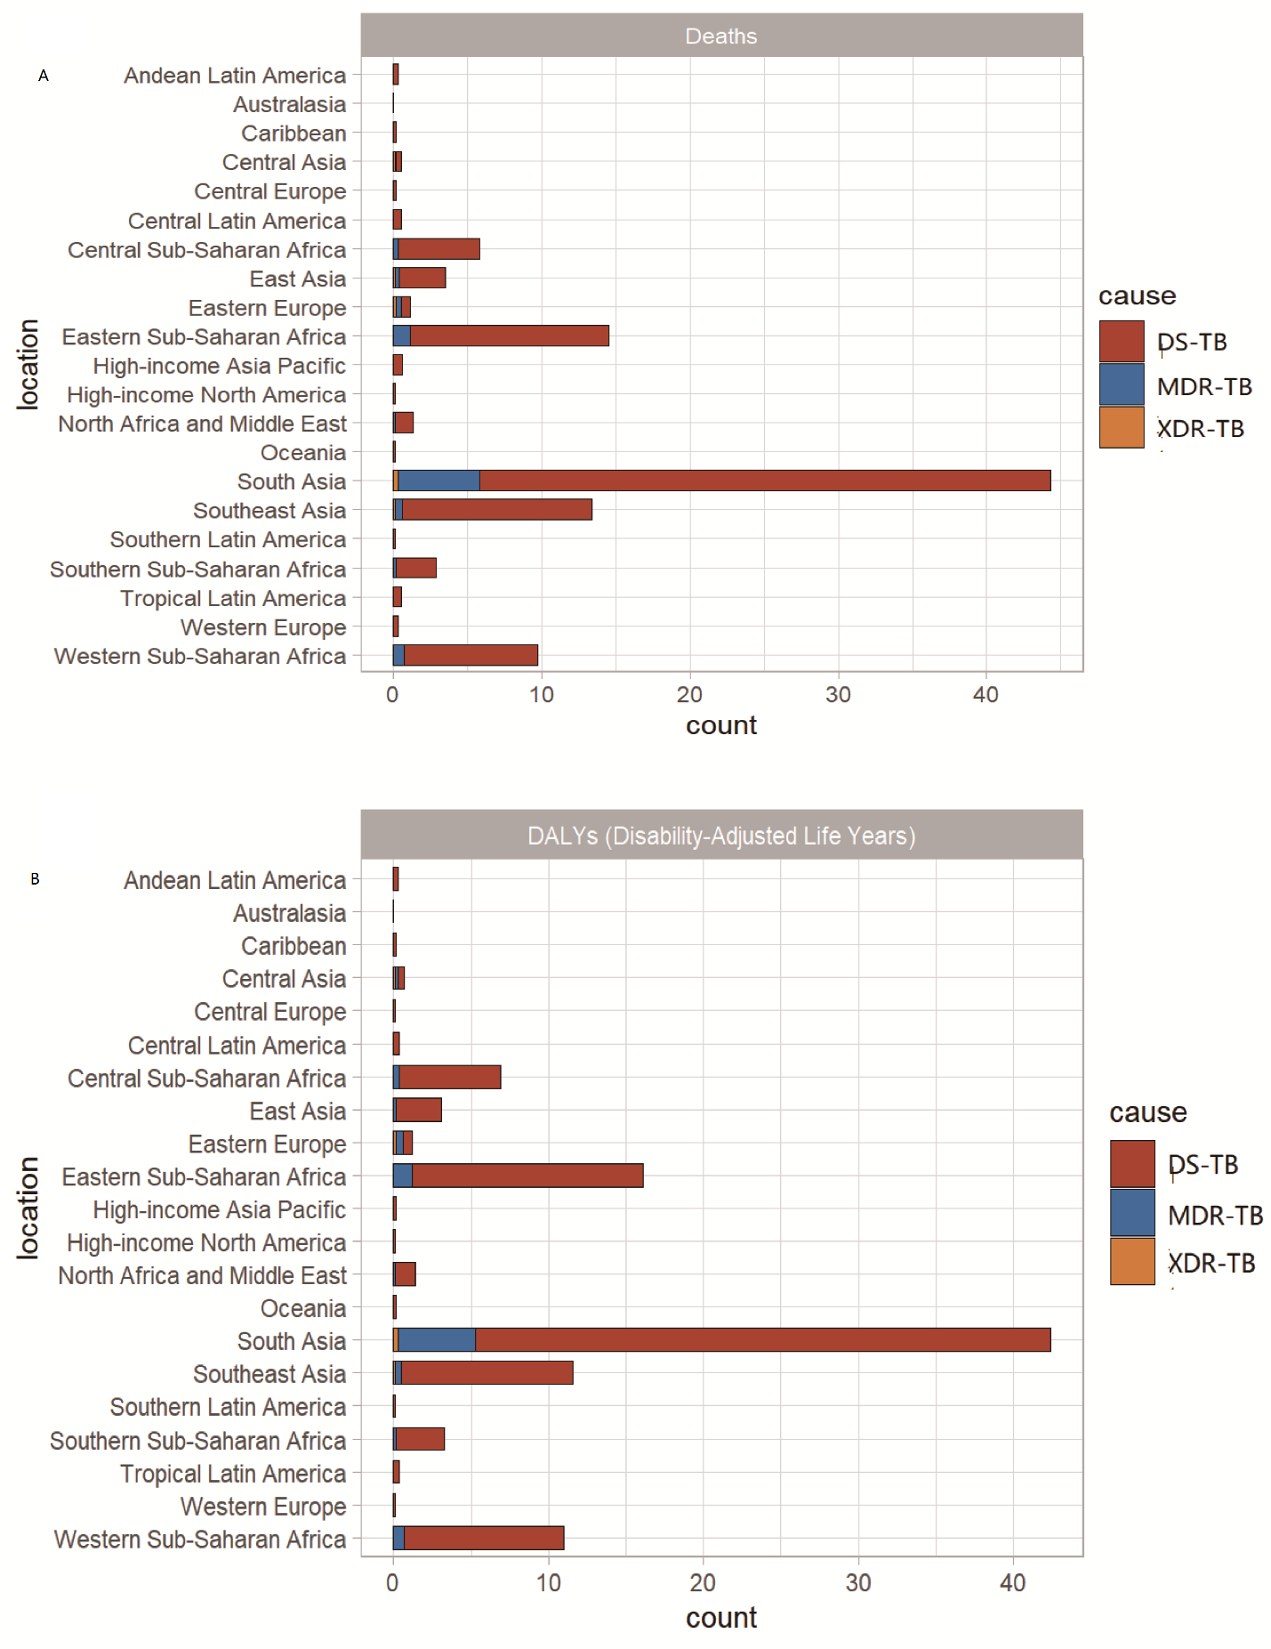Percentage of tuberculosis deaths (A) and DALY (B) attributable to 21 GBD regions, 2019. GBD, Global Burden of Diseases, Injuries, and Risk Factors Study.
The dataset that I will be using to conduct my analysis is well-suited for studying the relationship between socioeconomic factors and TB cases because it combines detailed epidemiological data with a wide range of socioeconomic indicators across multiple countries and years (2000–2024). It includes variables such as GDP per capita, health expenditure, access to health services, malnutrition prevalence, and urban population percentage—alongside TB incidence, mortality, and treatment outcomes. This enables a comprehensive analysis of how national-level economic and healthcare conditions correlate with TB burden. Although it lacks age-specific breakdowns, the dataset’s breadth and multidimensional nature make it ideal for identifying broader patterns and relationships between structural determinants and TB trends on a global scale.

Data Description
The dataset contains 3000 records with 22 attributes. There are 3 categorical variables and 19 numerical variables. By using df.info() function, it will give us a summary of the dataset. And by using df.describe() function, it will give us the descriptive statistic results. There’s no missing value and no duplicate (as per EDA report), but we can always double check to be sure. Other preprocessing steps will include: 1. Standardize categorical values to ensure consistent formatting of categories. 2. Check for any outliers (eg. boxplot) or wrong values. 3. Check for date consistency. 4. Check for equality in categories.
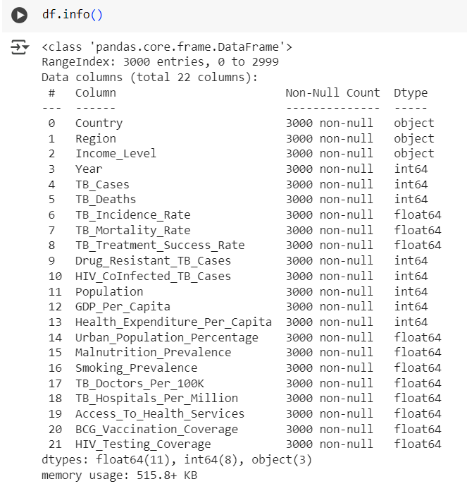
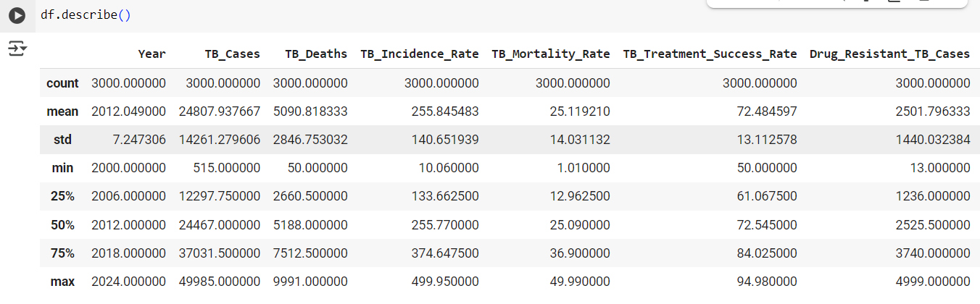

Project Approach
- Data Cleaning and Preprocessing.
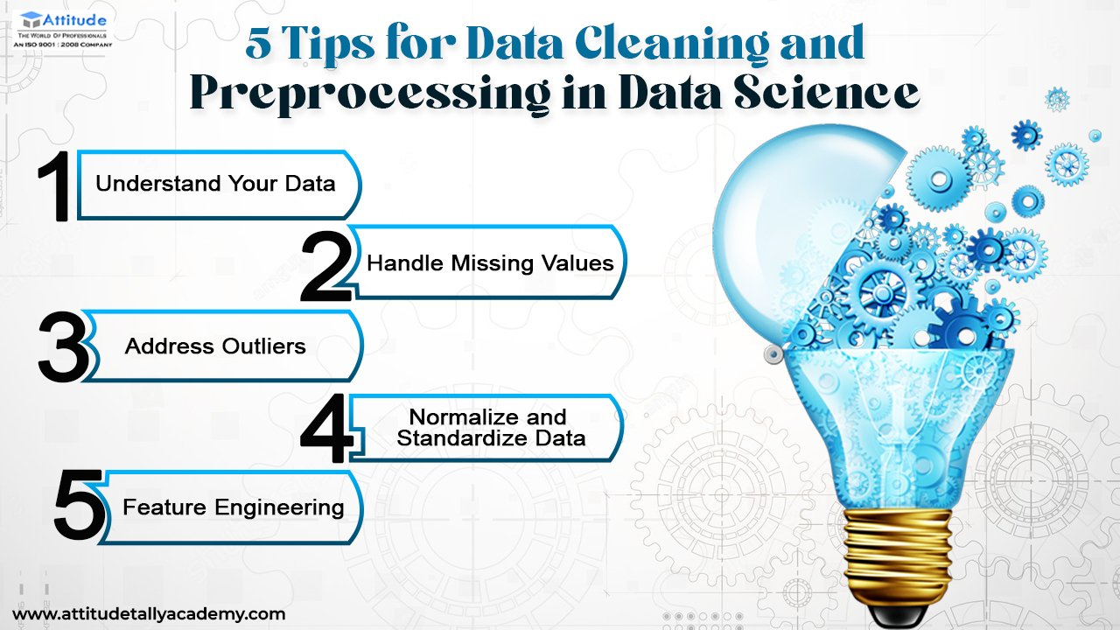
- EDA (Exploratory Data Analysis) that create visualizations to show relationships between attributes.
- Research Questions and Analytical Techniques:
  - For RQ1:
    - Will group data by ‘year’ and ‘income_level’ / ‘region’.
    - Use linear regression within each group to quantify trends.
    - Apply ANOVA to test whether trends differ significantly by income level or region.
    - Evaluate by using visualization patterns and R-Square/ p-values from linear models.
  - For RQ2:
    - Select potential predictors from the attributes.
    - Train model using multiple linear regression.
    - Perform feature scaling.
    - Evaluate by using R-Square/ p-values for model performance and feature importance ranking.
  - For RQ3:
    - Use multiple linear regression with dependent variable ‘TB_Mortality_Rate’, and independent variables such as ‘BCG_Vaccination_Coverage’, ‘Health_Expenditure_Per_Capita’, ‘GDP_Per_Capita’ etc.
    - Evaluate by using R-Square/ p-values and comparing models with and without ‘BCG_Vaccination_Coverage’.
- Use train-test split and cross-validation and evaluate models by using R-Squre etc.
- Interpret the result and discuss limitations.

References
World Health Organization: WHO & World Health Organization: WHO. (2025, March 14). Tuberculosis. https://www.who.int/news-room/fact-sheets/detail/tuberculosis
Tuberculosis: causes and how it spreads. (2025, January 17). Tuberculosis (TB). https://www.cdc.gov/tb/causes/index.html
Tuberculosis vaccine. (2024, June 14). Tuberculosis (TB). https://www.cdc.gov/tb/vaccines/index.html
HIV and Tuberculosis (TB) | NIH. (n.d.). https://hivinfo.nih.gov/understanding-hiv/fact-sheets/hiv-and-tuberculosis-tb
Bruchfeld, J., Correia-Neves, M., & Källenius, G. (2015). Tuberculosis and HIV Coinfection: Table 1. Cold Spring Harbor Perspectives in Medicine, 5(7), a017871. https://doi.org/10.1101/cshperspect.a017871
Silva, S., Arinaminpathy, N., Atun, R., Goosby, E., & Reid, M. (2021). Economic impact of tuberculosis mortality in 120 countries and the cost of not achieving the Sustainable Development Goals tuberculosis targets: a full-income analysis. The Lancet Global Health, 9(10), e1372–e1379. https://doi.org/10.1016/s2214-109x(21)00299-0
Khan, J., Aslam, F., Khan, B. T., Anjum, S. I., Rehman, F. U., Shams, W. A., & Ahmad, Z. (2015). A Study of Socio-Economic Status (SES) Associated with Epidemiology of Tuberculosis in General Population of District Buner, Khyber Pakhtunkhwa (KPK), Pakistan. Open Access Library Journal, 2(5), 1–8. https://doi.org/10.4236/OALIB.1101514
Global Burden of Tuberculosis From 1990 to 2019. (2022). https://doi.org/10.21203/rs.3.rs-1572451/v2
Lei, Y., Wang, J., Wang, Y., & Xu, C. (2023). Geographical evolutionary pathway of global tuberculosis incidence trends. BMC Public Health, 23(1). https://doi.org/10.1186/s12889-023-15553-7
Qu, M., Zhou, X., & Li, H. (2021). BCG vaccination strategies against tuberculosis: updates and perspectives. Human Vaccines & Immunotherapeutics, 17(12), 5284–5295. https://doi.org/10.1080/21645515.2021.2007711
Sharma, N. (2024, May 17). 5 Tips for data cleaning and preprocessing in data science. Attitude Academy. https://www.attitudetallyacademy.com/Blog/5-tips-for-data-cleaning-and-preprocessing-in-data-science/

